Board of Directors Annual Report – 2016/2017

The Board of Directors of the Kincardine and Community Health Care Foundation ( The Foundation) are fortunate to live in a community of generous organizations, business’ and individuals so we wish to take this opportunity to thank each and every one of them for their continued support.

Because of this tremendous support The Foundation was able to purchase the following equipment for the Kincardine Hospital.

ECG Lines | $1,000.00
Secured Chart) | $1,000.00
Portable DI (Wireless) | $239,000.00
CRDR mobile addition) | incl in above

HOSPITAL AUXILIARY

If you visit the gift shop at the Kincardine Hospital you see firsthand how committed the Auxiliary is to improving patient care in our community. Their carefully selected items are only one way in which this dedicated group of volunteers funded $31,610.00 worth of equipment listed below.

Pharmacy Department Fridge | $3,796.82
4 Additional IV Pumps | $17,400.00
Vital Signs Monitor | $8,110.19
Mammography chair | $1,757.60
Two wide based IV poles | $545.62

RADIOTHON

MYFM Kincardine Community Radiothon held its second successful event at Trillium Court with the support of our local radio station. Local business’, service groups and individuals joined together to accomplish our goal of $75,000. in order to purchase 4 Cardiac Monitors for the Nursing Department.

CRUISE NIGHT

Area residents and tourists filled downtown Kincardine on three Friday summer evenings to raise $4,030.at the 50/50 draw for their hospital. Lucky Winners of 2016 Cruise Night were;

Dave Guerard - $1340.
Bob Lung - $1300.
Brian Walker - $1390.

A great big thanks goes out to the Cruise Night Committee for allowing us to be a part of their fun filled nights.

BRUCE POWER GOLF TOURNAMENT

Kincardine and Saugeen Memorial Foundations once again benefited from the Bruce Power Golf Tournament raising $68,000.00 for each hospital. We wish to express our appreciation to all involved for playing a key role in supporting us each year.

ANNUAL FOUNDATION GRANTS

Generous donations received from grant applications are always a significant part of our proceeds. Thank you for considering our Foundation as these funds help us maintain the updated equipment for the Kincardine Hospital.

CHRISTMAS ORNAMENT CAMPAIGN

It wouldn’t seem like Christmas as you enter the hospital doors without our beautiful tree decorated by your generous donations. The ornaments hanging from its branches raised $34,670 .00 and brightened the entrance during the holiday season.

LOTTERY

Thank you to Sarah Chisholm for donating a gorgeous picture of our “Kincardine sunset” to be used as our raffle item. By selling tickets at several events around town we were able to raise $1,802.00.

PLANNED GIVING

Planned gifts can truly leave a legacy which positively affect the lives of so many patients. This was reflected in the contributions we received by way of memorial donations and family bequests. Thank you for including the Kincardine Hospital.

There are many ways you can make a lasting memorial that will result in significant benefits to your community hospital - Gifts of Securities; Gift of Life Insurance; Annuities or Bequests. Your personal tax situation, life goals and family considerations will all determine which type of gift is best for you. Before deciding on a course of action, we encourage you to seek professional legal, estate planning and financial advice.

ONGOING FOUNDATION ACTIVITIES

The Foundation continues to review policies, study investment strategies, look for fundraising ideas, and plan for future requirements at the Kincardine Hospital. By working with the SBGHC we strive to keep Kincardine Hospital well equipped to serve our residents.

FINANCIAL SUMMARY

The Foundation is pleased to provide the following fundraising and distribution summary for the 2017 year (year ending March 31, 2017). Our total assets as of March 31, 2017 are $5,984,720.

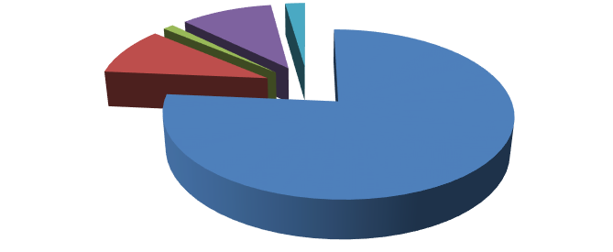
449,639
273,559
7,760
68,733
27,868
Donation and Fundraising
Interest, Dividends, Gains,
Investments
Expenditures Audit Fees
Travel, Education, Wages

THE BOARD OF DIRECTORS | MEMBERS OF THE FOUNDATION
Becky Fair –President  Jack Nancekivell – Vice President  Dorne Fitzsimmons – Treasurer  Merle Whitwell – Director  Dianne MacArthur – Director  Bob Lock – Director  Mary Hall – Director  Graham Mahood – Director  Maureen Ross - Director  Diane Baldwin – Foundation Coordinator | Lois Hackett  Gregg McClelland  Carol Collins  Jim Bagshaw

MISSION STATEMENT:

The Kincardine and Community Health Care Foundation is committed to the preservation and improvement of services at the Kincardine site through the administration of funds received through fund-raising activities and gratuitous gifts.

